Work Log: Computer Science 2.4 Assessment
Date: | What I did today: | Evidence:
11/06/2026 | Today I was looking at colour palettes for my mobile smart attendance website. I found three colour palettes that both had contrast with dark colours mixed with light colour, so it is easy to see text. I am still deciding between the three as I need to see which one would best suit my mobile app. | 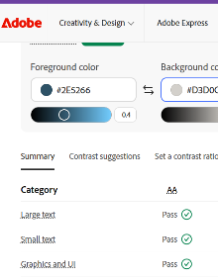  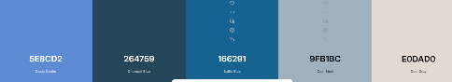  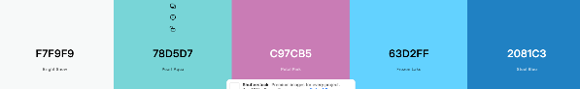  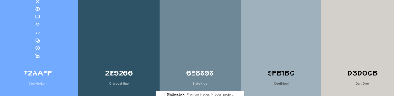
22/06/2026 | Today I started to work on my code. I first was working on the main smart attendance page for iPhone and laptops | 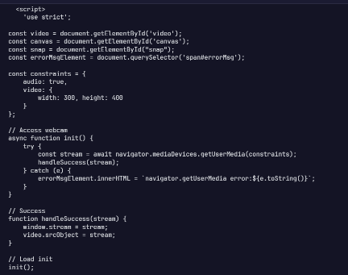  w

Complex errors:

